# Java Web Development Basics

# Regular Exam

# EXODIA

**EXODIA** (**E**nterprise **X**erox **O**pen **D**elivery **I**nformation **A**pplication) is an application which manages a queue of documents to be printed. Normally this process is managed by the printers (after all it’s the 21st century). However, some companies do not think like that and they use printers from BC. One such company is the **ORACLE** corporation (**O**bscurely **R**uthless **A**mateur **C**razy **L**unatic **E**mployees), which has hired you to implement the **EXODIA** application platform.

## Database Requirements

The **Database** of **EXODIA** needs to support **2 entities**:

### User

* Has an Id – a **UUID** String
* Has a Username
* Has a Password
* Has an Email

### Document

* Has an Id – a **UUID** String
* Has a Title – a String
* Has a Content – a String

Implement the entities with the **correct datatypes** and implement **repositories** for them.   
The Document’s Content should support very long strings.

## Page Requirements

### Index Page (logged-out user)

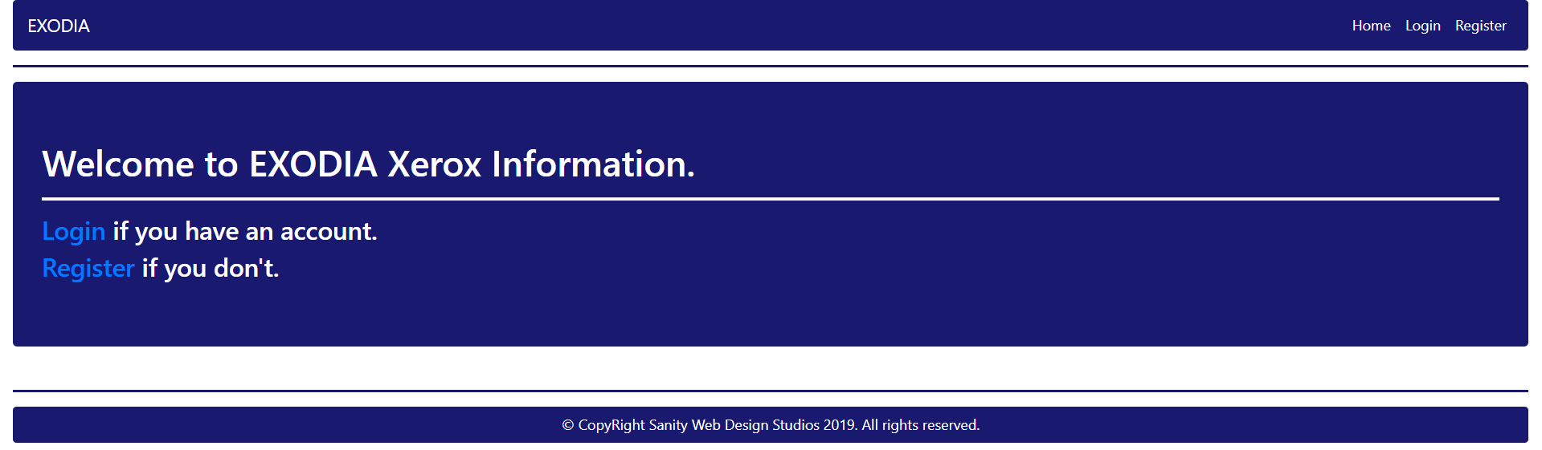

### Login Page (logged-out user)

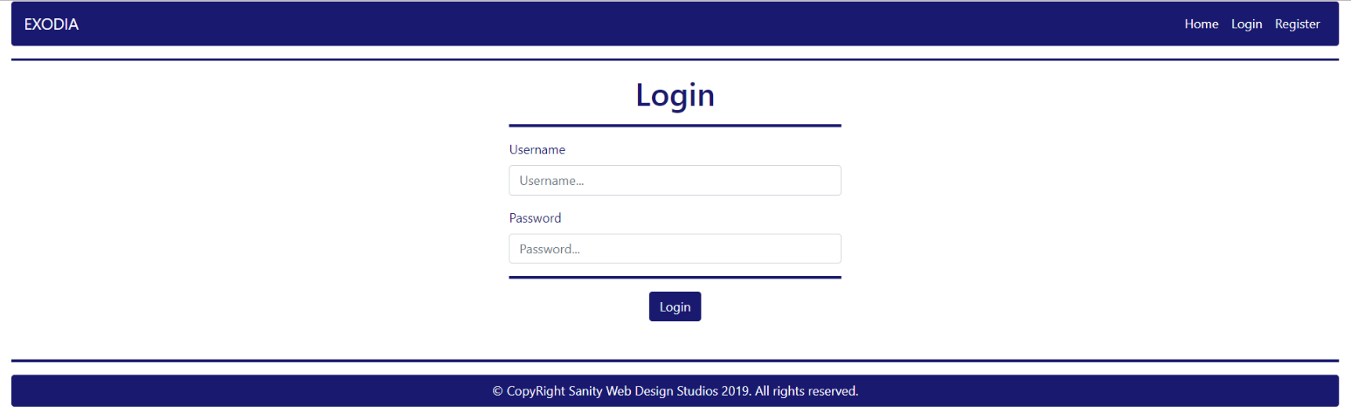

### Register Page (logged-out user)

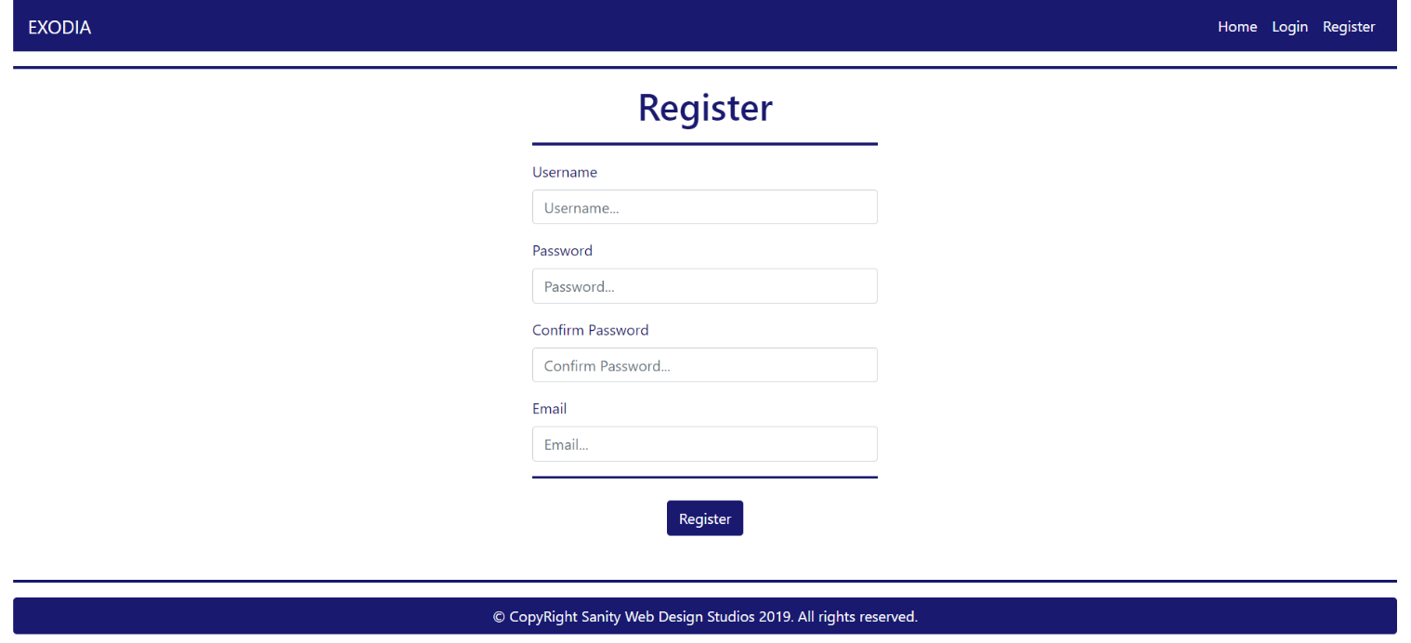

### Home Page (logged-in user)

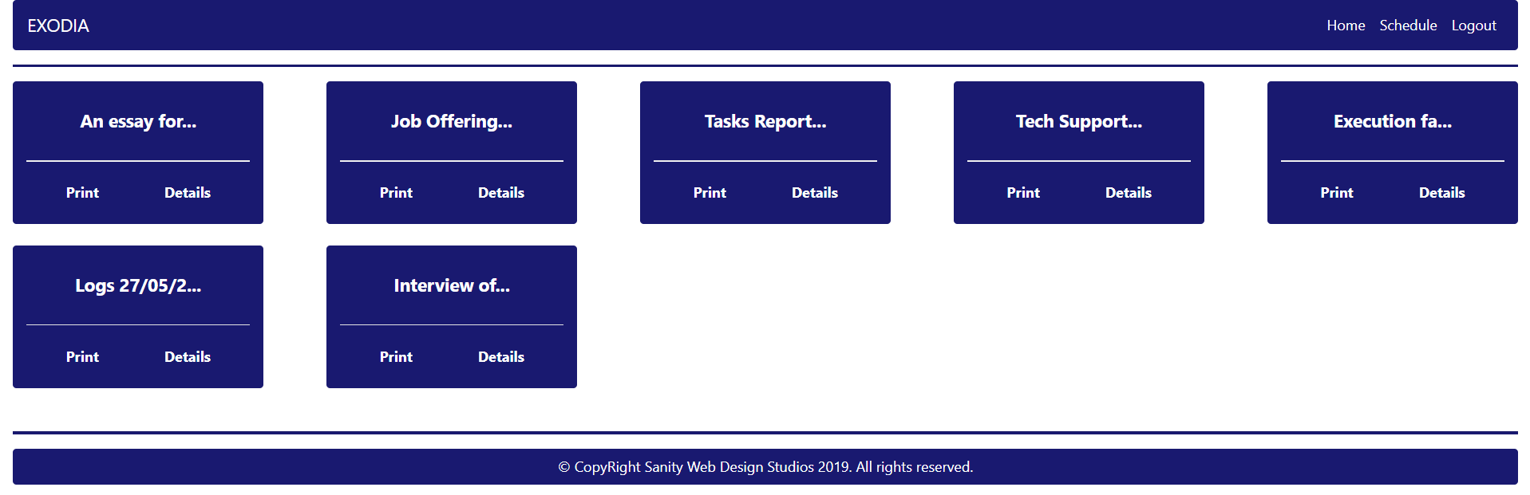

**NOTE**: As you can see the **elements** are **aligned** to the **left**, **regardless of their count**. The **maximum count** is **5 per** **row**, however they are **always aligned** to the **left**.

**NOTE**: The Documents’ Titles are **visualized** and **trimmed** to the **12-th symbol**, then **concatenated** with a "…" (**3 dots**).

### Schedule Page (logged-in user)

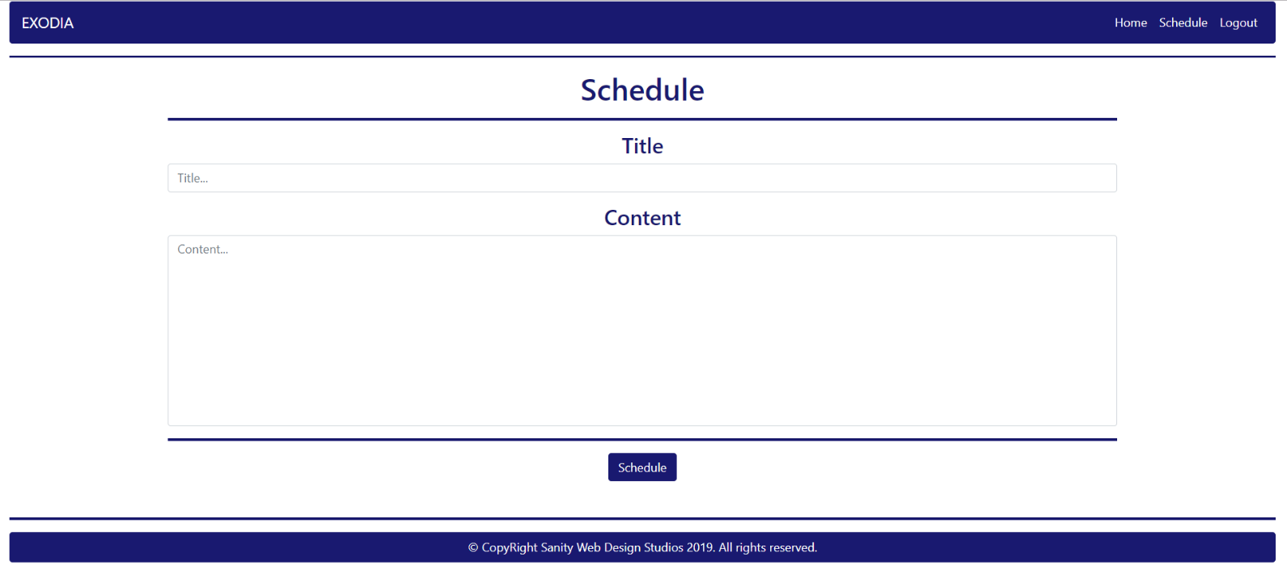

### Details Page (logged-in user)

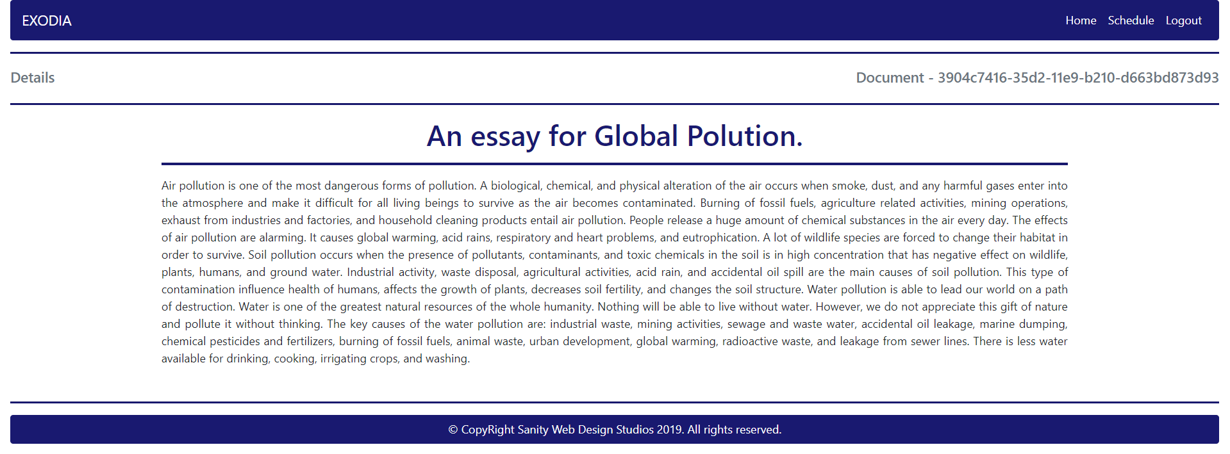

### Print Page (logged-in user)

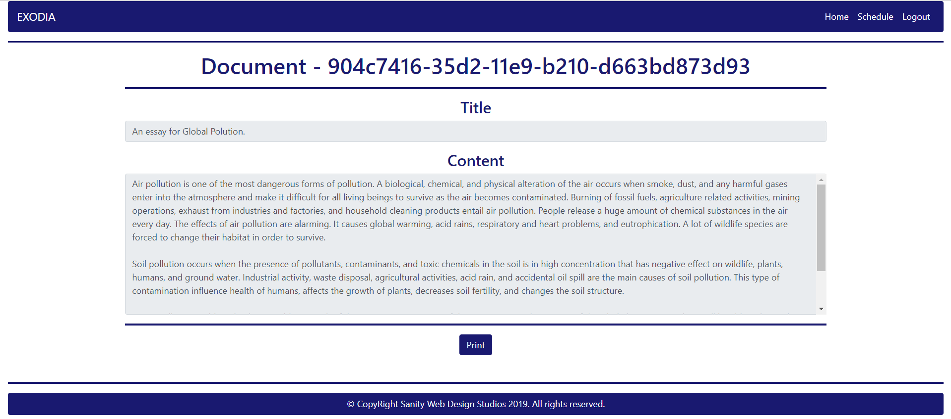

The templates have been given to you in the application skeleton, so make sure you implement the pages correctly.

**NOTE**: The templates should look **EXACTLY** as shown above.

**NOTE**: The templates do **NOT** **require** **additional** **CSS** for you to write. Only **bootstrap** and the **given css** are enough.

## Functionality

The functionality of EXODIA is very simple.

### Users

Guests can Register, Login and view the Index Page.

Users can Schedule Documents to be printed. Users can also see Scheduled Documents on the Home Page, where they can also Print or view Details about each one of them.

### Documents

Documents can be Scheduled for printing by Users. All Scheduled documents are visualized on the Home Page, each one in its own separate rectangular element.

Documents may contain large amounts of data so only their Titles are visualized on the Home Page. Their **Titles** are visualized up to the **12-th symbol**, followed by **3 dots** ("…").

Documents are visualized on the Home Page with 2 buttons – [Print] and [Details].

* The [Print] button leads to the Print Page – a simple confirmation-like page.
* The [Details] button leads to the Details Page – a simple details visualization page.

Printing a Document is like **deleting** it – it should be **removed** from the **database** of the **EXODIA** application.

### Redirections

* Upon successful Registration of a User, you should be redirected to the Login Page.
* Upon successful Login of a User, you should be redirected to the Home Page.
* Upon successful Scheduling of a Document, you should be redirected to the Document’s Details Page.
* Upon successful Printing of a Document, you should be redirected to the Home Page.
* Upon successful Logout of a User, you should be redirected to the Index Page.

### General

The **application** should **store** its **data** into a MySQL database, using Hibernate native.

## Security

The Security section mainly describes access requirements. Configurations about which users can access specific functionalities and pages.

* Guest (not logged in) users can access Index page.
* Guest (not logged in) users can access Login page.
* Guest (not logged in) users can access Register page.
* Users (logged in) cannot access Guest pages.
* Users (logged in) can access Home page.
* Users (logged in) can access Schedule page and functionality.
* Users (logged in) can access Print page and functionality.
* Users (logged in) can access Details page.
* Users (logged in) can access Logout functionality.

## Code Quality

Make sure you provide the best architecture possible. Structure your code into different modules, divide and conquer, follow the principles of high-quality code. You will be scored for the Code Quality and Architecture of your project.

## Bonus

The **ORACLE** corporation has given you a bonus task if you think that the whole **EXODIA** application is easy to implement.

Extend the Printing functionality by **sending** a **formatted PDF** of the Document to the User. All other functionality stays the same.

The formatting is simple:

* If you see a line starting with (from 1 to 6) "#", you should treat that line as a <h1> - <h6> element, and it should have a <hr> (horizontal line after it).
* If you see a line starting with a "*" (**star symbol**), you should treat that line as a <li> element inside a <ul> element.
* If you see text wrapped in "**" (double stars) you should make that text **bold**.

The Title of the Document should be rendered as a centered <h1> element with a <hr> element below it.

The Content of the Document should be **formatted** (as specified above) and rendered below the Title.

## Scoring

### Database – 10 points.

### Pages – 15 points.

### Functionality – 30 points.

### Security – 15 points.

### Code Quality – 30 points.

### Bonus – 10 points.